**The author's name.**

Alexey Panin

**Topic of the thesis.**

Adaption and integration of learning management systems (LMS) into teaching in Finnish secondary schools

**Supervisor (s).**

Dr. Nan (Andy) Zhang  
Assistant Professor,  
Department of Computer Science and Information Systems  
Faculty of Information Technology  
University of Jyväskylä

# SUBJECT

ICT – information and communication technology

LMS – learning management system

Adoption - the decision of an individual to make use of an innovation as the best course of action available. The process of adoption starts with initial hearing about an innovation to final adoption. (Rogers, 2003)

Integration - means of using any ICT tool (Internet, e-learning technologies, CD ROMs, etc) to assist teaching and learning (Williams, 2003).

# MOTIVATION

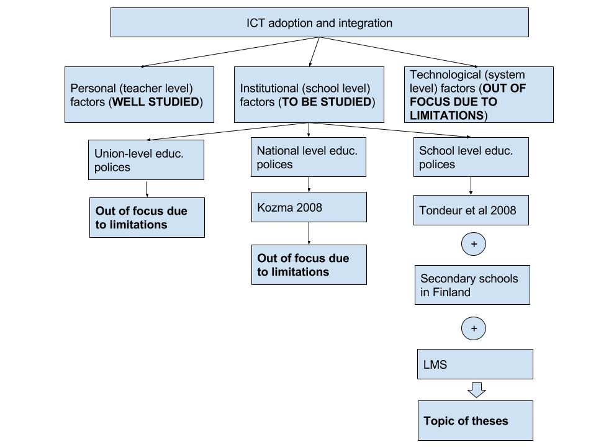Even though the ICT adoption and integration as a big section of scientific studies has been studied well during late years, modern sophisticated ICT solutions might bring their own challenges in understanding of their adoption and integration into different domains thus this topic doesn’t lose its relevance and still needs to be investigated. For the purpose of this study has been chosen the domain of education. Performed literature review of Buabeng-Ando (2012) identified that there are three main big group of factors influencing teachers’ adoption and integration of ICT into teaching: personal (teacher-level), institutional (school-level) and technological (system-level). As personal factors are concerned, in this study it is assumed that they have been studied well enough throughout performed various of studies and elaboration of various of theories like TAM and UTAUT so they are not focus of this study. Technological (system-level) factors has been studied significantly less but due to complexity of study which needs to be performed to study factors like rigid structure of traditional education system, traditional assessment, restrictive curricula, restricted organizational structure, technological factors are not the focus of this study neither. Schools, i.e. what happens inside of schools (school-level factors) are in their turn affected by different levels of polices: union-level if a country where a schools resides belongs to some union (like European Union), national-level and school level. The study of an effect of union or national-level polices on ICT adoption and integration into schools would require the study of schools of different countries what is unfeasible for this study due to the limitations.

Why education – because now there is a movement from teacher – centered view to student - centered view.

There has been developed great theories describing certain factors … But the reality is so that development and especially in IT sphere never stops and more and more sophisticated solutions (whether completely new or improved old ones) are appearing, available for people’s use and in completely different domains, for example as to medicine and education. That is why …

# Preliminary research questions.

**Does the usage of LMS differ between Finnish secondary schools with the same positive level of pedagogical attitude towards LMS usage but with or without ICT supporting local polices?**

(Does usage of LMS in schools with ICT supporting local polices and pedagogical positive attitude towards LMS usage differ from LMS usage of those schools where ICT support is not explicitly defined in local polices but pedagogical attitude towards using LMS is also positive? (comparison is done according to the type of LMS; schools using the same LMS are compared together)).

* Do school have polices which are supporting usage of LMS (ICT plan, leadership, training, monitoring of integration LMS into teaching, cooperation be-tween schools to share knowledge)?
* Is LMS, where in use, defined as a ‘core’ or ‘supplementary’ technology?
* How the process of choosing of ICT tools (focus on LMS) look like? Is that a bottom-up or up-to-bottom initiative?
* For what purposes do schools use LMS? (file sharing, submitting assignments, as a portfolio, platform for collaboration, for chatting, for organizing events, for providing materials according to student preferences (personalized learning), for analyzing / monitoring student success, for reducing teaching planning hours).

# The research method, if it can already draw.

# A few scientific sources.

* Felder, R. M., & Silverman, L. K. (1988). Learning and teaching styles in engineering education. Engineering education, 78(7), 674-681.
* Venkatesh, V., Morris, M. G., Davis, G. B., & Davis, F. D. (2003). User acceptance

of information technology: Toward a unified view. *MIS Quarterly,*

*27*(3), 425–478.

* Venkatesh, V., Thong, J. Y. L., & Xu, X. (2012). Consumer acceptance and use of

information technology: Extending the unified theory of acceptance and

use of technology. *MIS Quarterly, 36*(1), 157−178.

# Capacity to carry out the work.

My advantage in doing a research on the chosen topic is that I actually work in that company, so I have a possibility to collect more realistic data and have deeper insights. But what is my advantage can be a disadvantage as well: due to the work schedule, I have a limited time what I can dedicate for my theses writing, about 10 hours a week. Starting from next February this amount might be even smaller as I intend to be working full time. But my motivation to finish my theses by the end of 2016/2017 academic year is high, so I will do my best to make it happen.